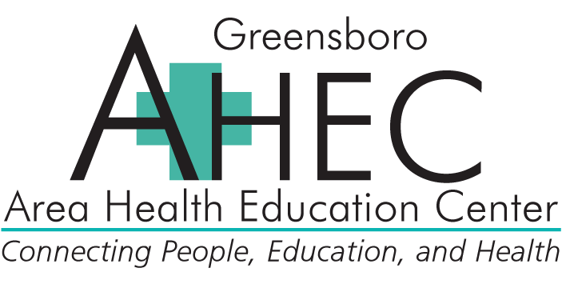

Clinical Care in 2015: HIV, Hepatitis C & Caring for Vulnerable Populations (45870)
Co-Sponsored by Greensboro AHEC and The University of North Carolina Eshelman School of Pharmacy

Event #: 45870-154644 (Pharmacist Session)

May 4, 2015
ACPE# 0046-9999-15-036-L02-P
(Pharmacist Session)
8:45 a.m. – 4:15 p.m. (Check-in at 8:00 a.m.)
7.0 contact hours

Faculty:
Christopher Hurt, MD, MPH, University of North Carolina at Chapel Hill School of Medicine
Lisa Hightow-Weidman, MD, MPH, University of North Carolina at Chapel Hill School of Medicine
Arlene Sena-Soberano, MD, MPH, University of North Carolina at Chapel Hill School of Medicine
Joseph Eron, MD, University of North Carolina at Chapel Hill School of Medicine
Heidi Swygard, MD, MPH, University of North Carolina at Chapel Hill School of Medicine
David Wohl, MD, University of North Carolina at Chapel Hill School of Medicine

Program Description:
The purpose of this symposium is to provide health care providers with an update on the care and treatment of HIV infected patients who are now living longer lives. Specifically, topics included will address: management of the HIV/Hep C co-infected patients, pre-exposure prophylaxis, STD update, syphilis/HIV, and caring for adolescent HIV+ patients. There will be a separate and second track for case managers, counselors, psychologists and substance abuse counselors who care for 2 or more HIV infected patients developed to address HIV related issues of HIV adolescent risk perception, support for an adolescent population and cultural competency.

Pharmacist Learning Objectives:
By the end of this knowledge-based conference, participants should be able to:
- Describe recent changes and advances in treatment of HIV patients.
- Discuss the ramifications of the HIV adolescent epidemic.
- Identify the complex medical issues in HIV/Hep C co-infected patients
- Discuss the clinical practice guidelines for the use of pre-exposure prophylaxis.
- Describe the complex social and behavioral issues associated with medication adherence
- Discuss the resurgence of syphilis in the MSM population.

Agenda:

Agenda:
8:00am Check-in
8:30 Welcome
8:45 HIV in America – Christopher Hurt, MD, MPH
9:30 Understanding the Adolescent Epidemic – Lisa Hightow-Weidman, MD, MPH
10:15 Break
10:30 Hepatitis C and HIV - TBD
11:15 Syndemic Syphilis and HIV – Arlene Sena Soberano, MD, MPH
12:00pm Break to Pick-up Lunch
12:15 LUNCH Breakouts
HIV and Hep C Case Discussions – Joseph Eron, MD
NC HIV/STD Disease Update – Heidi Swygard, MD, MPH
1:15 PrEP for Today: What We All Should Know – David Wohl, MD
2:30 Break
2:45 Ask the Experts Panel: Case Studies, Comorbid Hepatitis C and the Cultural of Youth – All Faculty
4:15 Wrap-Up and Adjourn

Location:
The Friday Center, 100 Friday Center Drive, Chapel Hill, NC

Target Audience:
Physician, Physician Assistants, Nurse Practitioners, Nurses, Pharmacists, Case Managers, Mental Health Care Providers, and anyone managing patients with HIV/AIDS.

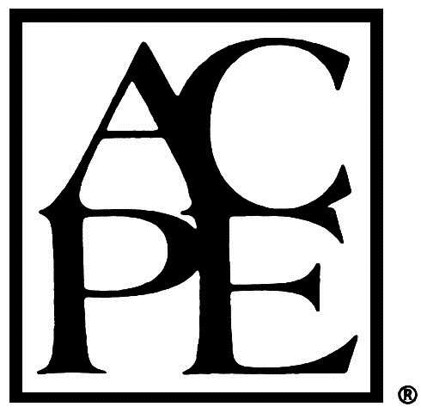
Continuing Education Credit for Pharmacists:
The University of North Carolina Eshelman School of Pharmacy is accredited by the Accreditation Council for Pharmacy Education as a provider of continuing pharmacy education. The knowledge-based program, ACPE # XXXX-XXXX-XX-XXX-XXX-X, will provide 7.0 hours of continuing pharmacy education credit. To receive ACPE credit, attendance must be acknowledged by completing the online evaluation. Statements of ACPE credit can be viewed and printed from CPE monitor on NABP.net. No partial credit will be given

Pharmacy Coordinator:
Pete Koval, PharmD
Director, Pharmacy Education
Greensboro AHEC

Fees:
$100 Early Bird Registration Fee; $125 after 4/3/15

Americans with Disability Act:
It is the policy of the Greensboro AHEC not to discriminate against any person on the basis of disabilities. If you need service or auxiliary aids mentioned in the Act in order to participate fully, please call us at 336-832-8025 at least three (3) weeks in advance of the program.

